Name:

Now the best code uses the least amount of blocks. For instance, on level 7 you win by placing five “forward” blocks for the angry bird.
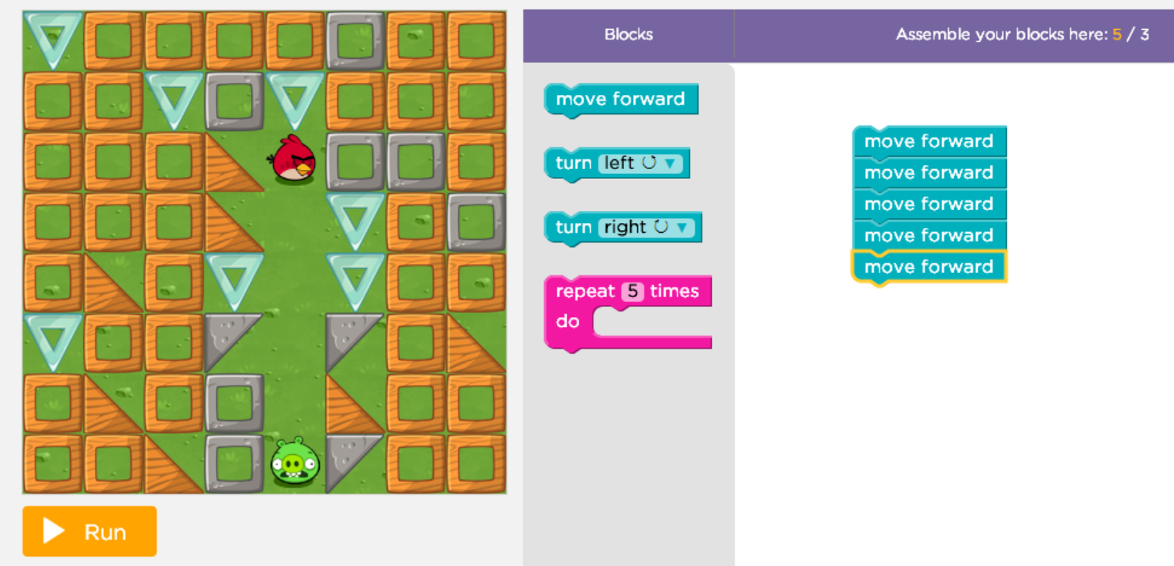

- How can you finish level 7 by only using 3 blocks?

- How did it feel to give instructions to the little objects?

- Would you consider becoming a Programmer someday?

