Math Applications for
1st & 4th Grades

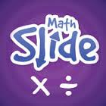

Math Slide: Multiplication & Division Facts is a multiplayer game helping children to learn and recall multiplication and division number facts. Players learn by sliding tiles into the center to match an answer, equation or image. The player who slides their tiles first wins.

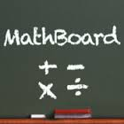
MathBoard® is a highly configurable math app appropriate for all school aged children. Beginning in kindergarten, with simple addition and subtraction problems, through elementary school where learning multiplication and division can be a real challenge. MathBoard will allow you to configure the app to best match the abilities of your individual child/student.

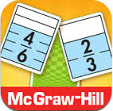
The Equivalent Fractions game by McGraw Hill offers a quick and easy way to practice and reinforce fraction concepts and relationships. This game runs on the iPad, iPhone, and iPod Touch. Players try to match equivalent fractions on cards showing halves, thirds, fourths, fifths, sixths, eighths, tenths, and twelfths. When cards are matched, they disappear and points are awarded. As cards disappear from the array, the cards behind them become accessible. The game ends when all cards are matched or no more matches can be made. Players earn extra points for making two or more matches in a row. To earn all possible points, players must clear the board!
Features of Equivalent Fractions:
- Fraction cards contain visual representations of fractions
- Ability to compare fraction cards by clicking and dragging
- Practices fraction concepts and relationships
- Correct and incorrect answer feedback
- Full tutorial
- Compatible with iPad, iPhone, and iPod Touch

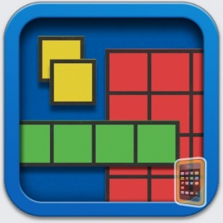
Number Pieces Basic
Number Pieces helps students develop a deeper understanding of place value while building their computation skills with multi-digit numbers. Students use the number pieces to represent multi-digit numbers, regroup, add, subtract, multiply, and divide.
Note: Number Pieces Basic, a simplified version of Number Pieces, is also available in the App Store. Number Pieces Basic is designed for primary students. It has fewer features, putting greater focus on place value, counting, addition, and subtraction.

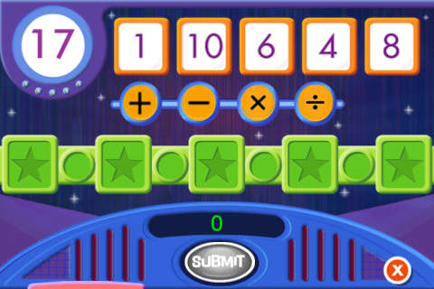
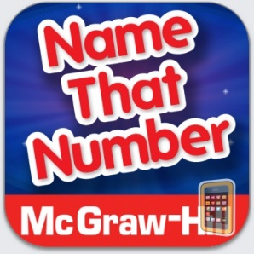
McGraw-Hill’s Name That Number game offers a fun and easy way to practice computation and order of operations. This computation practice game runs on the iPad, iPhone, and iPod Touch.
Players use five number tiles to build number sentences that equal a target number. Players can name the target number by adding, subtracting, multiplying, and/or dividing the numbers using as many tiles as possible. The more tiles the player uses, the more points he or she earns. There are a total of 5 rounds in a game. Visual and audio reinforcement of correct and incorrect answers helps players master math facts and order of operations.

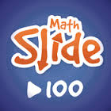
Math Slide is a multiplayer game helping children understand tens and ones; numbers up to 100. Players learn by sliding tiles into the center to match an answer, equation or image. The player who slides their tiles first wins.
Understanding tens and ones is a key math concept critical in a child’s development. Progressing from counting to using number facts and place value is difficult for many children. This app is specifically designed to help children make this critical progression, helping them ‘see’ and understand that 21 is 2 tens and 1 one and that one more than 79 is 8 groups of ten.
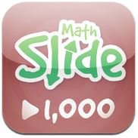
Math Slide: hundreds, tens & ones is a multiplayer game helping children understand hundreds, tens and ones; numbers up to a thousand. Players learn by sliding tiles into the center to match an answer, equation or image. The player who slides their tiles first wins.
Understanding hundreds, tens and ones is a key math concept critical in a child’s development. Progressing from numbers up to a hundred, understanding place value and using number facts with large numbers is difficult for many children. This app is specifically designed to help children make this critical progression in a fun way.

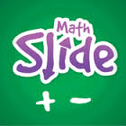
Math Slide: Addition & Subtraction Facts is a multiplayer game helping children to learn and recall addition and subtraction number facts. Players learn by sliding tiles into the center to match an answer, equation or image. The player who slides their tiles first wins.
Being able to quickly and easily recall addition and subtraction number facts is a key math skill critical in a child’s development. Children are unlikely to progress without learning these key facts. This app is specifically designed to help children learn this critical skill.

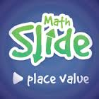
Math Slide is a multiplayer game helping children understanding place value of numbers up to 1,000. This School Edition contains the same games as Math Slide: tens & ones and Math Slide: Hundreds, tens & ones. Players learn by sliding tiles into the center to match an answer, equation or image. The player who slides their tiles first wins. Fully understanding hundreds, tens & ones is essential to progressing and succeeding at math. Progressing from counting to using number facts and place value is difficult for many children. This app is specifically designed to help children make this critical progression, helping them ‘see’ and understand that 21 is 2 tens and 1 one and that 7 hundreds, 11 tens and 3 ones is 813.

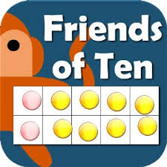
Little Monkey Apps Friends of Ten is an activity to be used in the early years of schooling to introduce an early understanding of numbers to ten, counting objects to ten, subitising - recognising a collection of objects without counting them, counting on from a higher number, partitioning of objects and the combinations that make ten 8+2, 2+8, 1+9, 3+7 etc. These skills underpin mental addition and subtraction.
The importance of recalling number combinations that make ten are that students use strategies for addition, that is, knowing that 7+3 is the same as 8+2. This introduces the idea of patterns and compensation (one up, one down). These activities develop the concept that addition and subtraction are linked.
Little Monkey Apps Friends of Ten can be used in the traditional classroom to collaborate with a small group or used by individual learners. For both types of users, a written record such as poster or chart collating knowledge of what was said previously allows revisiting and adding to knowledge.
Little Monkey Apps Friends of Ten is designed to encourage verbal communication about discoveries and build upon previous knowledge. Little Monkey Apps Friends of Ten tasks are often best utilised through the Threading technique. That is the task is to be used 2 or 3 times a week for a few minutes each time over a period of time. The student(s) are therefore familiar with the structure of the activity but the challenge is new each time. This technique allows students to construct their own learning.

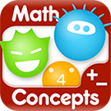
Dexteria Dots - Get in Touch with Math
Dexteria Dots is a fun, intuitive math game that teaches the concepts of number sense, addition, subtraction, and relative size. Equally playable on iPhone or iPad, the app will appeal to kids from age 2-8. Fast fingers earn bonus dots as the player masters a variety of challenges and difficulty levels. Parents, teachers, and OTs will love it, too!

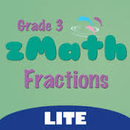
ZMath Fractions is the most comprehensive fractions application designed for Grade 3. It helps 3rd graders learn and improve their fraction skills. zMath Fractions provides a fun, simple and interactive environment for learning.
Topics include:
1. Learning Fractions using shapes
2. Understanding Fractions using Number Line
3. Comparing Fractions
4. Adding and Subtracting Fractions
5. Mixed Numbers
6. Word Problems
7. Equivalent Fractions

Native Numbers *** Top Rank of #2 in Education! 10,000,000 math tasks completed and counting *** WHAT THE EXPERTS ARE SAYING
- 12 BEST Children's Educational Apps of 2012: “Native Numbers is a fabulous app, promoting deeper learning and providing a much needed foundation in math for all children.” - TeachersWithApps.com
- “The kids loved the gameplay feel of the app… This is a great app to help young kids learn the concept of numbers and basic math skills.” -iHeartThisApp.com
- "A Math App Worth Bragging About!" - Karen Mahon, Ed. D, Learning Scientist

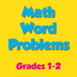
Word problems grade 1-2 visual math
Prepare your child to soar in school with this app.
This app let's children solve real-world problems involving addition and subtraction of whole numbers. The majority of math problems on a standardized test is word problems. The four sets in solving a word problem is understand, plan, solve and look back.
This app contains the basic fundamentals of learning and will result in academic success.

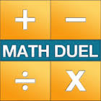
Math Duel is a split screen mathematics game that pits two players against each other on the same device! Change settings for each player to level the playing field. New single player mode is great for fun math practice! The split-screen interface is a perfect fit for your iPad!
FEATURES:
● Split Screen Mode (iPad)
● Single Player Mode
● Track Accuracy and Speed
● Highly Configurable
● Customized Equations

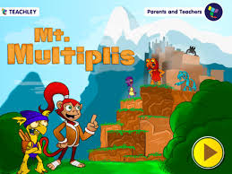
Teachley: Mt. Multiplis “Mt. Multiplis is not just focused on getting the answer, but also understanding the process of multiplication and the strategies that kids need to develop. About the game: Linka gets caught in a terrible storm while flying home after a successful treasure hunt. She escapes but her plane isn’t as lucky. Help Linka make her way through Mt. Multiplis by building bridges, unlocking treasure, and earning gems. Rebuild Linka’s plane by collecting the pieces from the greedy Crags who live on the island.

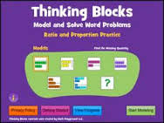
Thinking Blocks Addition teaches children how to model and solve word problems involving addition and subtraction. In this interactive tutorial, children are introduced to 6 problem solving models. The models help children organize information and visualize number relationships. While Thinking Blocks Addition may be used with any elementary math program, it is ideal for children who are learning model drawing strategies found in math books from Singapore. Thinking Blocks Addition is best suited for children, ages 6 to 9.

©dubon101.weebly.com

