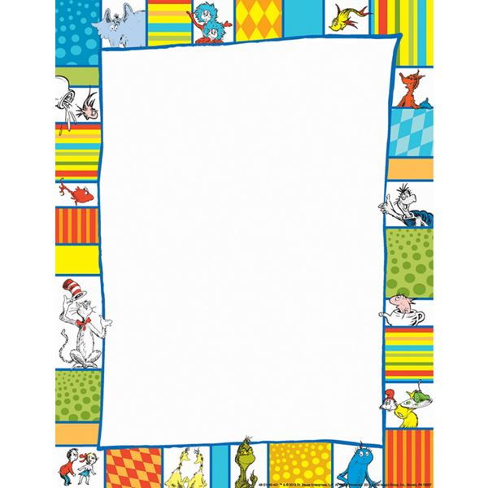

Congratulations!

Name:

Date:

Ms. Dubon’s Technology Class