Name:
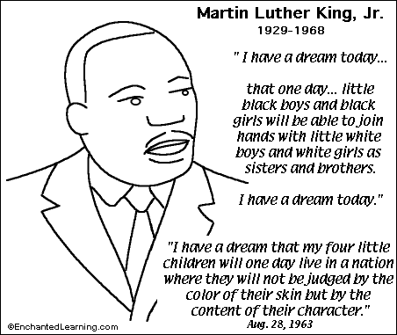

Timeline of martin Luther King Jr.’s Life
1929
1948
1953
1955
1956
1958
1963
1964
1968
1986

